


Anguilla Maritime Administration
& Shipping Registry

AMASR

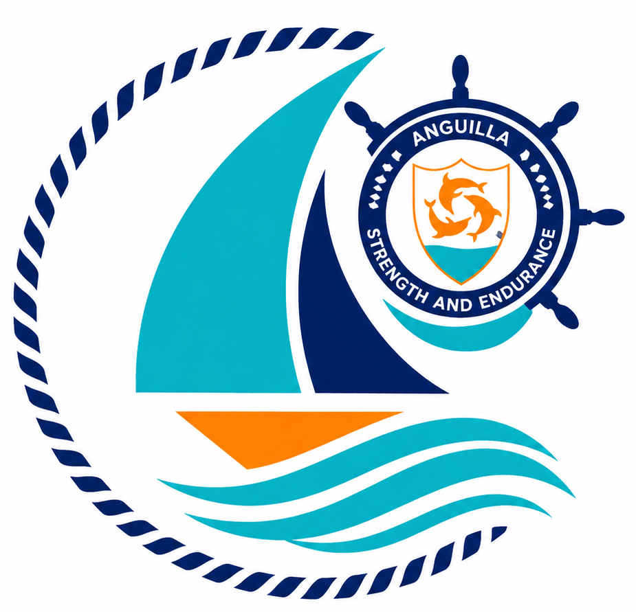

Form: | Application for Instrument Transfer or Discharge
No.: | 04
Rev.: | 00
Date: | 2026-06-10
To: | Recognized Organizations, Shipowners, Managers, Masters, Seafarers, Partners, Brokers, Surveyors, and the general public.

Strength and Endurance

Address: Anguilla Maritime Administration
Anguilla, Leeward Islands, Ministry of Infrastructure, Communications, Utilities and Housing, Coronation Avenue, The Valley Anguilla
Tel: +447454760022| Email: info@amasr.ai

FORM 04 - APPLICATION FOR INSTRUMENT TRANSFER OR DISCHARGE
Please complete this form in its entirety, electronically or in block capitals.

1. Vessel details
Vessel name
IMO number (or HIN as available)
Official Number

2. Instrument details
Type of instrument (mortgage
or lease)
Agreement date
(DD/MM/YYYY)
For mortgages only:
Sum secured by the Instrument
Priority n.
3. Mortgagee/Lessee details
Name
Address
Company registration n.
4. Mortgagor/Lessor details
Name
Address
Company registration n.
5. Applicant declaration
I hereby apply for the: Transfer; or Discharge
of the instrument, particulars of which are given above, from the AnguillaShip Register.
Signatory full name in block letters
Signatory Role

- Mortgagee (signatory in case of mortgage)

- Lessor (signatory in case of leasing)

- POA - provided as applicable
Date |  | Signature

Note: Refer also to the guidance notes overleaf.
- This form constitutes the document to be recorded with the Anguilla Register of Ships and, accordingly, must faithfully and fully reflect all details set forth in the instrument agreement.
- The form must be properly completed and signed by the mortgagee or, as applicable, by the lessor.
- The form must be submitted together with the instrument discharge or transfer agreement, duly executed with the required formalities (notarization of signature and apostille) and payment of the applicable fees.
- Find below an example of an acceptable statement of notarization of the signature by a notary, we highly suggest to use such draft if possible:
On this [DATE], before me the undersigned, a Notary Public in [LOCATION], personally appeared [Mr./Ms.][NAME OF THE REPRESENTATIVE], [TITLE] of [COMPANY NAME], to me known to be the
identical person who executed the foregoing instrument and acknowledged to me that [he/she] executed the same as [his/her] free and voluntary act and deed on behalf of [COMPANY NAME], for the uses and purposes set forth therein. I further attest and certify that I personally know [Mr./Ms.][NAME OF THE REPRESENTATIVE], to be the [TITLE] of [COMPANY NAME], that [he/she] is fully empowered to execute the foregoing [DECLARATION/APPLICATION FORM] in [his/her] capacity as [TITLE] of [COMPANY NAME], and that [he/she] is fully authorized to bind [COMPANY NAME] to the provisions of this [DECLARATION/APPLICATION FORM]. Given of my hand and seal on the day and year last above written [Notary Public].
- Where two or more vessels are the subject of a single instrument or one vessel is the subject of two or more instruments, a separate application shall be submitted for each vessel or each mortgage.
- If the application is acceptable, the Administration shall proceed to the relevant registration and shall notify the parties thereof.

